Date: |  | Client number:  (NB. Client name and address to be recorded separately) |  |  | Portfolio ref: |  |  | Therapist:
Reason for Consultation:

Client expectations:

Demographic:  Tick as appropriate | Male or Female |  | Pre-adolescent | Adolescent |  | Adult | Older Adult |  | Special population
GP name and address:

Previous medical history:

Medication:

SUBJECTIVE EXAMINATION

Date of birth: | Occupation: | Sports and hobbies:
Any other lifestyle information: (alcohol, smoking, nutrition, working environment etc.)

Client objectives for treatment: (aches and pains, areas of discomfort, functional problems)

I confirm the above information is correct to the best of my knowledge. I consent to continue with a physical examination.
Note. A chaperone must be in attendance when the client is under the age of 18 years
Client signature: |  | Therapist signature:
Chaperone name: |  | Chaperone signature:

OBJECTIVE ASSESSMENT

State at Rest: (Any pain, discomfort) | Initial Observation (Face, Posture, Gait):
Observation: (asymmetry, swelling, redness, deformities)  Palpation: (skin temperature, oedema, tension) | Movement Patterns: (active range of movement, reduced function)
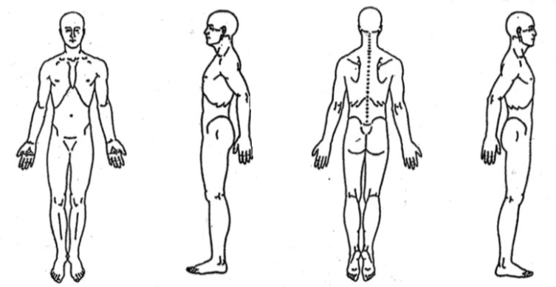
Postural observations:

ANALYSIS AND PLAN

Problem list (Summary of findings):

Treatment Plan: (Areas to be worked on, timings, techniques to be used, client position, supports etc.)
Note this is the information the client requires in order to make an informed decision at continuing with the treatment or not. It should be discussed with and agreed by the client before continuing.

Informed consent:
The treatment options have been discussed and I give my consent for treatment to continue:

Client signature:

LEVEL 3 : | Effleurage | Petrissage | Tapotement | Compressions
(highlight techniques used | Vibrations | Passive Stretching | Frictions

Location: Massage Room/clinic/pitch side/changing room?

Massage Medium:

Changes to treatment plan and findings during treatment:

Reassessment: (change in range of movement, pain levels, emotional state)

After care advice:

Client comments/feedback:

Evaluation of effectiveness of treatment:

Future revisions to treatment plan:

Self-evaluation:

Any other comments:

Therapist’s Signature:

